**Project Report Format**

1. **INTRODUCTION**
   1. Project Overview
   2. Purpose
2. **IDEATION PHASE**
   1. Problem Statement
   2. Empathy Map Canvas
   3. Brainstorming
3. **REQUIREMENT ANALYSIS**
   1. Customer Journey Map
   2. Solution Requirement
   3. Data Flow Diagram3.4. Technology Stack

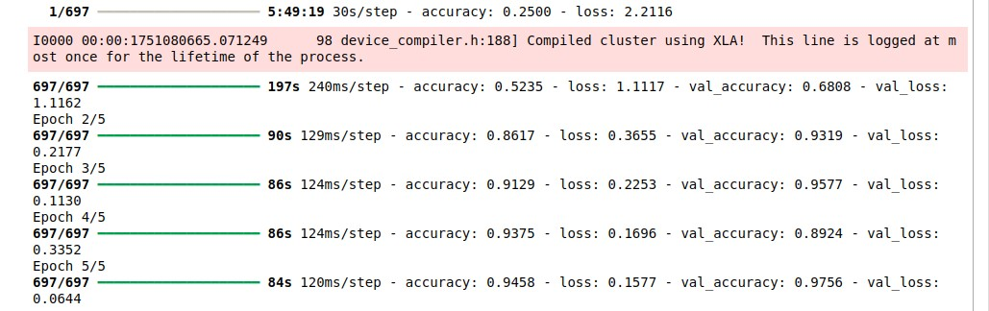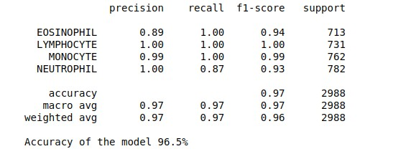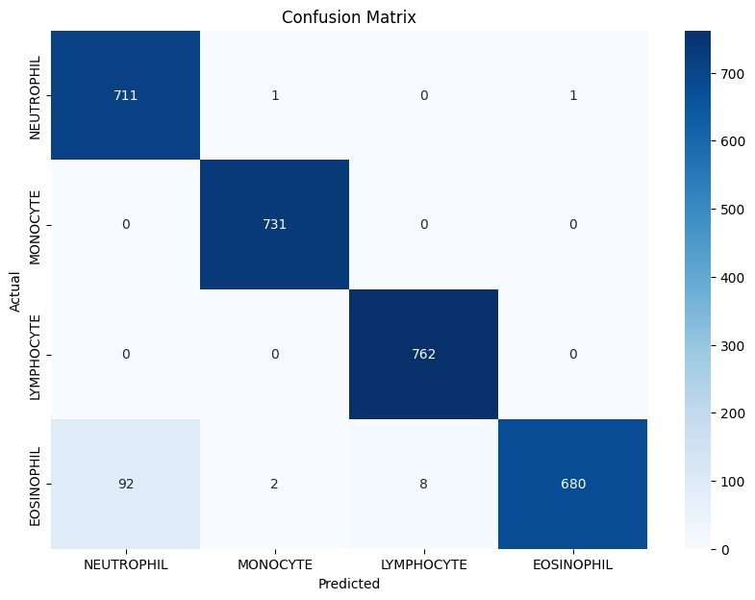

1. **PROJECT DESIGN**
   1. Problem Solution Fit
   2. Proposed Solution
   3. Solution Architecture
2. **PROJECT PLANNING & SCHEDULING**
   1. Project Planning
3. **FUNCTIONAL AND PERFORMANCE TESTING**
   1. Performance Testing

**7.RESULTS**

# ADVANTAGES & DISADVANTAGES

✅ **Advantages:**

1. **Accurate Predictions**: Uses MobileNetV2, a lightweight yet efficient deep learning model for blood cell classification.
2. **User-Friendly Interface**: Simple and intuitive web UI accessible by lab technicians and students without technical expertise.
3. **Fast Processing**: Predictions are generated within seconds on local systems.
4. **Cost-Effective**: No need for cloud infrastructure; runs on local machine.
5. **Offline Capability**: Once set up, can be run without internet connection.
6. **Extendable**: Easy to expand with additional classes or integrate cloud/database in future.

❌ **Disadvantages:**

1. **Local-Only Deployment**: The app is not yet deployed on cloud or accessible remotely.
2. **Inference-Only System**: Model training and fine-tuning are done separately and not integrated into the app.
3. **Dataset Limitations**: Accuracy may drop if the underlying dataset is small or unbalanced.
4. **No Real-Time Camera Input**: Requires manual file upload instead of live microscope or webcam feed.
5. **Not Yet Mobile-Friendly**: Current UI is not optimized for mobile screens.

# CONCLUSION

The HematoVision project successfully demonstrates an AI-powered system for blood cell classification using transfer learning. A pre-trained MobileNetV2 model enables accurate classification of eosinophils, lymphocytes, monocytes, and neutrophils from uploaded images. The web app, developed using Flask, provides a simple interface for uploading images and viewing results in real time. The system is designed to be efficient, easy to use, and runs entirely on local machines.

# FUTURE SCOPE

* **Model Enhancement**: Train with larger and more diverse blood cell datasets to increase classification accuracy.
* **Mobile App Version**: Develop a responsive Android/iOS app to allow broader field or clinical usage.
* **Live Microscope Feed Integration**: Enable live image analysis via webcam or digital microscope.
* **Report Generation**: Automatically create and download classification reports for analysis or sharing.
* **Multilingual Interface**: Add support for regional languages to improve accessibility for diverse user groups.

# APPENDIX

🔹 **Source Code**

The complete source code is organized into multiple files, including:

* Flask backend (app.py)
* Model prediction logic (utils.py)
* HTML templates (home.html, result.html)
* TensorFlow MobileNetV2 model (Blood_Cell.h5)

🔹 **GitHub & Project Demo Link**

* GitHub Repository: https://github.com/Nagendra4126/Nagendra4126-HematoVision-Advanced-Blood-Cell-Classification-Using-Transfer-Learning.git